 

**Cairo University**

**Faculty of Computers and Artificial Intelligence**

**Information Systems Department**

**Graduation Project Report**

**LEARNHUB**

By

*Ahmed Mohamed NegmEldin* 20200049

*Belal Mohamed Soliman* 20200115

*Hagger Esmail Hassan* 20200611

*Mahmoud Salah Ahmed* 20180254

*Mohamed Omar Ahmed* 20201154

*Osama Karam Karam* 20200071

**Under the Supervisors of:**

**Dr. Laila Abdelrahman Mohamed Esheiba**

**TA. Ibrahim Gomaa**

*Department of Information Systems, Faculty of Computers and Artificial Intelligence, Cairo University, Egypt*

**Abstract**

This graduation project introduces an e-learning platform designed to elevate the educational experience. The platform features online courses, automated essay correction in both Arabic and English, a dynamic statistical dashboard for educators, and automated parental notifications regarding student progress.

Our platform facilitates flexible online learning, offering a variety of courses to cater to students' interests. A notable innovation is the automated essay correction system, utilizing advanced language processing for prompt feedback and efficient grading in both Arabic and English.

To empower educators, the platform includes a dynamic dashboard providing real-time insights into student performance. Additionally, an automated communication system informs parents about their child's academic achievements, attendance, and overall progress. In cases where a student opts not to pursue higher education, the system prompts parental engagement for exploring alternative paths.

In summary, this project presents a comprehensive e-learning solution, leveraging technology to enhance learning, automate assessments, and strengthen the connection between educational institutions and parents. The platform contributes to a more efficient and communicative educational ecosystem.

Table of Contents

Chapter 1 Introduction 5

**1.1** **Background and Motivation** 5

**1.2** **Problem Statement** 6

**1.3** **Objectives** 6

**1.4** **Project Scope and Limitations** 7

**1.5** **Tools And Technologies** 9

**1.6** **Project Methodology** 12

Chapter 2 Market and Literature Survey 13

**2.1** **Related Work** 13

**2.2 SWOT Analysis** 15

**2.3** **System Features:** 17

Chapter 3 LearnHub Analysis 19

**3.1 Use case model** 19

3.1.1 Use case description 20

**3.2 Requirements Analysis** 27

3.2.1 Functional Requirements 27

3.2.2 Non-Functional Requirements 28

**3.3 Essay Correction Model Description** 29

**3.4 Stakeholders** 30

**3.5** **User Profiles** 31

**3.6** **Personas** 32

Chapter 4 LearnHub Design and Implementation 34

**4.1** **Class Diagram** 34

**4.2** **Sequence Diagram** 35

**4.3** **System Architecture** 40

**4.4** **Model Architecture** 40

**4.5** **Entity-Relationship Diagram (ERD)** 41

**4.6** **Activity Diagram** 42

**4.7** **UI Prototype** 44

**List of Figures**

Figure 1 Agile Methodology 12

Figure 2 Persona 1 32

Figure 3 Persona 2 33

Figure 4 Class Diagram 34

Figure 5 make quiz sequence diagram. 35

Figure 6 See student grades sequence diagram. 36

Figure 7 See student statistics on dashboard sequence diagram. 37

Figure 8 upload course materials sequence diagram. 38

Figure 9 view course materials sequence diagram. 38

Figure 10 view grades sequence diagram. 39

Figure 11 System Architecture 40

Figure 12 Model Architecture 40

Figure 13 ERD Diagram 41

Figure 14 Activity Diagram1 42

Figure 15 Activity Diagram2 43

**List of Tables**

Table 1 Comparison Table 15

Table 2 User Profiles 31

# Introduction

In today's digital age, education is undergoing a transformative shift with the integration of technology. This project aims to develop a comprehensive website that caters to the needs of students, instructors, and parents. By leveraging technology, the website will enhance communication, streamline administrative tasks, and improve the overall educational experience. It will feature an exam module with intelligent auto-correct capabilities for efficient grading. The user-friendly dashboard will provide insightful statistics and progress reports for personalized learning. Automated notifications will keep parents informed about their child's grades and progress. This website aims to revolutionize education by addressing traditional challenges and empowering learners and educators. Through digital transformation, we aim to enhance the educational journey for the next generation.

* 1. **Background and Motivation**

The background of this comprehensive educational website lies in the recognition of the limitations and challenges faced by traditional educational systems. Outdated evaluation methods, limited communication channels between teachers and parents, and a lack of personalized learning experiences have hindered students' potential and created a disconnect in the education process.

Motivated by a deep desire to address these challenges, our team embarked on developing an advanced educational website. By embracing the power of technology, we aim to create a transformative learning environment that seamlessly integrates various educational tools and resources.

Our motivation stems from the belief that education should be accessible, engaging, and tailored to the individual needs of each learner. Through this platform, we strive to empower students, teachers, and parents by providing personalized learning experiences, efficient assessment methods, and improved communication channels. By leveraging the potential of technology, we envision a future where education becomes a truly inclusive and empowering journey for all.

* 1. **Problem Statement**

The problem we are addressing with our comprehensive educational website is the inefficiency and ineffectiveness of traditional educational systems. These systems often lack personalized learning experiences, effective communication channels between teachers and parents, and modern evaluation methods. As a result, students' potential is hindered, their engagement in the learning process is compromised, and there is a significant gap in addressing individual learning needs.

Moreover, the reliance on outdated educational practices restricts access to quality education, particularly in underserved communities where resources and opportunities are limited. This perpetuates educational inequalities and prevents students from reaching their full potential.

Recognizing the urgent need for change, our mission is to create a solution that revolutionizes the education landscape by providing a technology-driven platform that addresses these key challenges. By offering personalized learning experiences, efficient assessment methods, and improved communication channels, we aim to bridge the gap in education and empower learners of all backgrounds to thrive in the 21st century.

* 1. **Objectives**

The primary objective of this project is to design and develop an innovative e-learning platform that aims to revolutionize the educational experience. In a world where traditional methods of question generation and grading can be time-consuming and resource-intensive for instructors, our project seeks to address this challenge with a multifaceted approach. Our key objectives include the development of:

* Automated Question Generation System: This system will generate multiple-choice questions (MCQ) and essay questions from the questions provided by instructors (doctors), enhancing the efficiency and scalability of content creation.
* **NLP-Powered** Automated Grading: Implementing Natural Language Processing (NLP) techniques to enable automatic evaluation and grading of both MCQ and essay questions. This not only reduces the manual grading workload for instructors but also provides students with immediate, consistent feedback.
* Student Performance Dashboard: Building an intuitive dashboard that empowers instructors to monitor and assess students' academic progress within the subject.
  1. **Project Scope and Limitations**

1. **Utilizing Natural Language Processing (NLP) techniques:**

This projectwould involve implementing algorithms and models that can assess and grade student responses in a natural language format, such as essays or short answers, without human intervention. NLP enables the system to understand the content, context, and language used in these responses, allowing for automated evaluation and grading.

1. Accessibility through Web Browsers

The project's scope ensures that the e-learning platform is accessible through common web browsers. It aims to provide a seamless experience for users on a variety of devices, including desktop computers, laptops, tablets, and smartphones.

**Project Limitations**

1. Device and Internet Access:

One limitation is that the effectiveness of the e-learning platform depends on users having access to compatible devices and a stable internet connection. Students without access to such resources may face limitations in their ability to participate fully.

1. Browser Compatibility

The platform's functionality may vary based on the web browser used. While efforts will be made to optimize compatibility, there may be variations in user experiences on different browsers.

1. NLP Accuracy

The NLP-powered automated grading system, while efficient, may not achieve human-level accuracy in evaluating student responses. Certain nuances, context, or subjective elements in student answers may present challenges for automated grading.

1. Data Privacy

Ensuring the privacy and security of user data is paramount. However, despite robust security measures, data breaches and vulnerabilities are ever-present risks in any online system.

1. Budget and Resources

The project operates within predefined budget constraints, which may limit the implementation of certain features or the scalability of the platform. Resource constraints, including personnel and technology, could affect the project's scope.

1. User Training

While efforts will be made to create a user-friendly interface, the need for users to adapt to the platform may present challenges. Adequate training and support mechanisms must be in place to address this limitation.

1. Technical Support and Maintenance

Providing ongoing technical support and maintenance for the platform is essential. However, limitations in the availability of support resources and the ability to address technical issues promptly may impact the user experience.

1. Scalability and Performance

As the user base grows, the platform's performance and scalability may be tested. Ensuring that the system can accommodate a large number of concurrent users without compromising performance is a potential limitation.

* 1. **Tools And Technologies**

1. **HTML, CSS, JS**The core technologies for building the user interface and defining the structure, styling, and interactivity of the dashboard.
2. **React**is a popular JavaScript library for building interactive and dynamic user interfaces for websites and web applications. It is often used for front-end development and is known for its component-based architecture. React has gained popularity for its flexibility, performance optimizations, and developer-friendly features, making it a top choice for building modern and responsive front-end interfaces for websites and web applications.
3. **ASP.NET Core**a versatile and powerful framework for building back-end server applications and services. It offers a wide range of tools, libraries, and technologies that make it a popular choice for developing robust and scalable back-end systems.  
   .NET is a mature and reliable framework that follows an Architecture and for building back-end solutions, and it's well-suited for a wide range of applications, from web services and APIs to microservices and cloud-native applications.   
   It offers a combination of performance, scalability, and cross-platform support that makes It a strong choice for back-end development in a variety of industries.
4. **MS SQL Server**  
   MS SQL Server is a widely used relational database management system developed by Microsoft. It can serve as a powerful tool in the project to store and retrieve data, manage essays, corrections, and user data efficiently.  
   It is known for its scalability, speed, and ease of use.
5. **python**

Python is a high-level, interpreted language valued for its simplicity, readability, and versatility across various domains including web development, data analysis, and artificial intelligence.

1. **draw.io**

Selected for creating diagrams, visualizing, and communicating complex concepts.

1. **GitHub**

We selected GitHub as the primary tool for version control and collaboration in our project. GitHub is a widely used web-based platform that provides Git repository hosting, allowing us to securely store, track changes easily, manage branches and manage our project's source code.

1. **Postman**

Selected for its powerful API testing capabilities, allowing us to test, validate, and debug our APIs efficiently, ensuring their functionality and performance.

**Types of data and methods used for building the machine learning model:**

**1. User input data:**

The software program needs to allow for user input, such as the submission of reports, assignments and the uploading of quizzes and materials.

**2.** **Machine learning libraries**:

The project can use several machine learning libraries such as:

**a. SCIPY and NLTK**: Deep learning frameworks like TensorFlow and PyTorch can be used to develop more advanced models, such as recurrent neural networks (RNNs) or transformers, for essay evaluation.

**b. Scikit-learn:** Scikit-Learn is a widely used Python library for machine learning tasks, and it can be employed for building classification models to assess the quality and correctness of essays.

**3. Evaluation Metrics:**Assess the model's performance using evaluation metrics like Mean Absolute Error (MAE) or Root Mean Square Error (RMSE) to measure the difference between predicted and actual scores.

**4. Natural Language Processing (NLP) Libraries:**

**a. NLTK (Natural Language Toolkit):** NLTK is a popular Python library for NLP that provides various tools for tasks like tokenization, part-of-speech tagging, and syntactic parsing.

**b. Spacy:** Spacy is another NLP library for Python, known for its speed and efficiency. It can be used for tasks like named entity recognition and dependency parsing.

* 1. **Project Methodology**

A project management methodology is a set of principles and practices that guide you in organizing your projects to ensure their optimum performance. Basically, it is a framework that helps you to manage your project in the best way possible. This section demonstrates which methodology will be used during the project implementation. and why? In our project, an agile methodology could be used to develop the application. Agile is a project management approach that emphasizes collaboration, flexibility, and continuous delivery. It allows the development team to work iteratively and adjust the project based on feedback from stakeholders. It helps significantly improve the quality of our software at each release.

**Agile methodology steps:**

**Requirements gathering:** The development team would collaborate with professors, parents, and other stakeholders to understand their needs and requirements for the application.

**Sprint planning**: The development team would then plan a series of sprints, where they would identify the most key features to be developed in each sprint.

**Development:** During each sprint, the development team would work on building the application, and continuously test and refine the features to ensure they meet the requirements and expectations of stakeholders.

**Feedback and iteration:** Throughout the development process, the development team would receive feedback from stakeholders, and use this feedback to make improvements and adjustments to the application.

**Deployment:** Once the application has been developed and tested, it can be deployed for use.

By using an agile methodology, the development team can ensure that the application is being developed in a flexible, collaborative, and iterative manner, which will help to ensure that it meets the needs and requirements of stakeholders, and ultimately achieve its goal enhancing the educational journey for the next generation.

Figure 1 Agile Methodology

# Market and Literature Survey

"LearnHub" is an innovative online platform designed to empower professors with comprehensive tools for course management, material uploading, and assessment facilitation. Professors can effortlessly add and organize courses, seamlessly upload course materials, and integrate quizzes with ease. One of the standout features of LearnHub is its advanced Natural Language Processing (NLP) techniques that enable automatic correction of quizzes, even for essay questions. This cutting-edge functionality streamlines the grading process, saving valuable time for educators while providing timely feedback to students. With LearnHub, professors can focus more on delivering quality instruction and fostering engaging learning experiences, knowing that the platform efficiently handles the assessment process.

1. **Related Work**
2. **Blackboard**

* **Goals:** Blackboard is an educational technology company that provides learning management systems (LMS) and other software solutions for educational institutions. The primary goal of Blackboard is to enhance teaching and learning experiences by providing a platform where educators can deliver course materials, facilitate communication and collaboration among students, administer assessments, track student progress, and manage various aspects of the educational process in a digital environment. Some specific goals of Blackboard include Facilitating online learning, enhancing communication and collaboration, Streamlining course management.
* **Features**
* A popular LMS for higher education.
* Supports course creation, assignments, and grading.
* Offers assessment and analytics tools.
* Integrates with video conferencing solutions.
* Course Content Management
* Communication Tools
* Mobile Accessibility Integration with Third-Party Tools

1. **Moodle**

* **Goals:** Moodle is an open-source learning management system (LMS) that aims to provide educators with a flexible platform for creating online learning environments. The primary goal of Moodle is to support teaching and learning by providing a comprehensive set of tools and features that facilitate communication, collaboration, content delivery, assessment, and administration within educational settings. Some of the key goals of Moodle include Facilitating Online Learning, Promoting Collaboration and Interaction, Enhancing Access to Educational Resources, Streamlining Course Management, Promoting Personalized Learning, Fostering a Community of Learning.
* **Features:**
* Supports course creation, assignments, and quizzes.
* Provides analytics for tracking learner performance.
* Allows integration with video conferencing tools like Zoom.
* Course Management
* Assessment and Evaluation
* Grading and Feedback
* Mobile Accessibility

1. **Canvas**

* **Goals:** Canvas is a learning management system (LMS) developed by Instructure with the goal of providing educators and students with a flexible and user-friendly platform for teaching and learning. The primary goal of Canvas is to support and enhance the educational experience by offering a wide range of tools and features that facilitate communication, collaboration, content delivery, assessment, and administration within educational settings. Some key goals of Canvas include Facilitating Online Learning, Supporting Different Learning Styles, Enhancing Collaboration and Communication, Streamlining Course Management, Promoting Personalized Learning, fostering a Community of Learning, Ensuring Accessibility.
* **Features**
* A robust LMS for educational institutions.
* Offers course creation, grading, and communication tools.
* Provides analytics and reporting for instructors.
* Can integrate with video conferencing tools and third-party apps.
* Content Authoring
* Assessment and Evaluation
* Gradebook

Table 1 Comparison Table

|  |  |  |  |  |  |  |
| --- | --- | --- | --- | --- | --- | --- |
|  | Essay Correction | MCQ Correction | Notification And Alerts | Accessibility | Dashboard | Mobile Application |
| **LearnHub** |  |  |  |  |  |  |
| Blackboard |  |  |  |  |  |  |
| Moodle |  |  |  |  |  |  |
| Canvas |  |  |  |  |  |  |

**2.2 SWOT Analysis**

A SWOT analysis is a strategic planning tool used to evaluate the Strengths, Weaknesses, Opportunities, and Threats of a project or business. Here is a sample SWOT analysis of our software program:

**Strengths:**

* **Comprehensive Feature Set:** The LMP offers a wide range of features, including user authentication, course management, content organization, and educational tools, making it a versatile educational platform.
* **Essay Question Correction**
* **Scalability:** The system can handle a large number of users and courses, ensuring it can grow as the user base expands.
* **Accessibility:** The system will be user-friendly.
* **Integration Capabilities:** It seamlessly integrates with third-party services like Google Workspace and Microsoft Office, enhancing its utility.

**Weaknesses:**

* **Competition**: with established platforms like Blackboard.
* **Complexity**: The extensive feature set may overwhelm some users, particularly those who are not tech or new to online learning.
* **Performance Optimization**: Ensuring optimal performance, especially with multimedia content, can be a challenging task and may require constant monitoring and fine-tuning.
* **Security Concerns**: Handling sensitive educational data, the LMP must maintain a high level of security. Any breaches or vulnerabilities could have severe consequences.
* **Maintenance Requirements**: Regular updates and improvements may be resource-intensive, and a failure to keep the system up to date could lead to technical issues and user dissatisfaction.
* Need for continuous performance **optimization**.

**Opportunities:**

* **Meeting the demand** for flexible and remote learning.
* **Customization Services**: Offering customization options for educational institutions to tailor the platform to their specific needs.
* **Enhanced User Experience**: Continual UX improvements and the addition of user-friendly features can lead to higher user satisfaction.
* **Data Analytics**: Leveraging the data collected on user behavior and performance can lead to insights that improve the learning experience and inform future development.
* **Collaboration with Educational Institutions**: Partnering with educational institutions for research and development opportunities can lead to innovations in online learning technology.

**Threats:**

* **Competition**: The online learning market is highly competitive, and new or existing competitors could develop similar or superior features.
* **Data Breaches**: Security threats and data breaches can result in legal consequences, damage to reputation, and loss of user trust.
* **Rapid technological changes**: Rapid advancements in technology may require constant updates and investments to keep the LMP up to date.
* **User Resistance to Change**: Users, particularly educators and students, may resist transitioning from traditional teaching methods to an online platform.

**2.3 System Features:**

* **User Authentication:**
  + **Description**: The system must provide user registration and login mechanisms to allow access to the platform.
  + **Users** can create accounts, log in securely, and reset their passwords if forgotten.
* **Course Management:**
  + **Description**: Instructors should be able to create, modify, and remove courses, and students must have the ability to enroll in these courses.
  + **Instructors** can create courses, students can enroll, and the platform prevents unauthorized access.
* **Content Management:**
  + Description: Instructors can upload, organize, and manage course materials, supporting various file formats and multimedia content.
  + Instructors can upload content, organize it, and students can access it.
* **Assessment and Grading:**
  + **Description**: The system should allow the creation and management of quizzes, assignments, exams, with auto-grading for multiple-choice questions and for essay questions. (given the optimal solution for these questions)
  + **Instructors** can create assessments, and students receive accurate grades.
* **Progress Tracking:**
  + **Description**: Both instructors and students should have access to progress dashboards and analytics to monitor performance
  + **Users** can track progress, access courses related data.
* **Notifications and Alerts:** 
  + **Description**: The system must send notifications and alerts for significant events
  + receive notifications for assignments and deadlines.

# LearnHub Analysis

**3.1 Use case model**

**Figure 3. Use Case Example**

|  |  |
| --- | --- |
| **ID** | UC 1 |
| **Title** | Enroll In Course. |
| **Description** | The student wants to enroll in course after browsing courses. |
| **Primary Actor/s** | Student. |
| **Pre-conditions** | * The student has access to the system and is logged in. * The student browsed courses and has completed prerequisites for this course that he wants to enroll in. |
| **Flow of Events** | 1. The student accesses the e-learning website and logs into his account. 2. The student navigates to the "Courses" section to browse available courses. 3. The student may use search filters or browse categories to find a specific course. 4. The student clicks on a course to view detailed information, including course description and instructor details. 5. If the course has prerequisites, the system checks whether the student meets them. 6. The system displays a confirmation prompt. 7. The student confirms his intention to enroll in the course. 8. The student gains access to course materials, which may include lectures, readings, assignments, and quizzes. |
| **Post-conditions** | * The student has successfully enrolled in the course after searching or browsing courses. * The student can access course material and see his progress. |
| **Assumptions and Constraints:** | * The user has a valid account and is authenticated before attempting to enroll in a course. * The courses listed on the platform are currently available and can be enrolled in by the users. * The availability of the e-learning platform may be constrained by server maintenance schedules or unexpected downtime. |

* + 1. **Use case description.**

|  |  |
| --- | --- |
| **ID** | UC 2 |
| **Title** | Take Quiz. |
| **Description** | The student engages in a quiz within a course on the e-learning platform. Quizzes are designed to assess the student's understanding of the course material and contribute to their overall learning progress. |
| **Primary Actor/s** | Student. |
| **Pre-conditions** | * The student must be successfully logged into his account on the e-learning platform. * The student must be enrolled in the course for which the quiz is intended. * The quiz must be made available by the instructor and accessible to the student based on the course progress. |
| **Flow of Events** | 1. The student accesses the e-learning platform, logs into their account, and navigates to the specific course for which they intend to take the quiz. 2. Within the course interface, the student locates the "Quiz" section or relevant module that contains the quiz they wish to take. 3. The student clicks on the quiz to view details such as the number of questions, time limit, and any specific instructions provided by the instructor. 4. The student initiates the quiz, and the system presents the first question along with answer options. 5. The student answers each question by selecting the appropriate response from the available options or writing the answers if there are essay questions. 6. The system allows the student to navigate between questions, review and modify his answers before final submission. 7. Upon completing all the questions or reaching the time limit, the student submits the quiz for evaluation. 8. Depending on the quiz settings, the system may provide immediate feedback on correct and incorrect answers. 9. The system displays the quiz results to the student, showing the score achieved and any correct/incorrect answers. |
| **Post-conditions** | * The student has submitted the quiz for evaluation. * The system displays the results, including the score achieved and, if applicable, correct/incorrect answers. * The student's overall course progress is updated to reflect the completion of the quiz. |
| **Assumptions and Constraints:** | * The quiz questions and structure remain unchanged during the student's quiz-taking session. * It is assumed that the student has a stable internet connection throughout the quiz-taking process. * The student is responsible for managing their time during the quiz, adhering to any time limits specified. * The quiz is assumed to adhere to the settings configured by the instructor, such as time limits, question types, and feedback options. * The quiz-taking process may be constrained by potential technical issues, including server downtimes or connectivity problems. |

|  |  |
| --- | --- |
| **ID** | UC 3 |
| **Title** | View Progress of Student. |
| **Description** | Parents want to monitor and assess the academic performance and progress of their children within the e-learning platform. Parents can gain insights into enrolled courses, completion status, and, if available, more detailed information such as grades and feedback from instructors. |
| **Primary Actor/s** | Parent. |
| **Pre-conditions** | * The parent must be successfully logged into their account on the e-learning platform. * The parent must be associated with the student's account, indicating a parent-child relationship within the platform. * The student (child) must be enrolled in at least one course on the e-learning platform. |
| **Flow of Events** | 1. The parent accesses the e-learning platform and logs into their parent account using valid credentials. 2. Within the parent dashboard or navigation menu, the parent locates and clicks on the "Student Progress". 3. If the parent has more than one associated student, they may select the specific student for whom they want to view progress. 4. The system displays an overview of the student's academic progress, including enrolled courses and completion status. 5. The parent can click on individual courses to view more detailed progress information, such as grades, completion percentages, and any available feedback. 6. The parent has the option to navigate back to the parent dashboard or home screen for an overall view of the e-learning platform. |
| **Post-conditions** | * The system displays the academic progress of the student, including course completion status and any relevant performance metrics. |
| **Assumptions and Constraints:** | * It is assumed that the parent has a stable internet connection throughout the process of viewing the student's progress. * The system assumes the integrity of the parent-child relationship, ensuring that the parent has legitimate access to view the progress of the associated student. * The progress displayed is assumed to accurately represent the student's advancement within enrolled courses. * The system assumes adherence to data privacy and security measures, ensuring that student information is only accessible to authorized parents. * The process of viewing a student's progress may be constrained by potential technical issues, including server downtimes or connectivity problems. * The parent's interaction with the platform may be limited to viewing progress only. * The parent is assumed to have limited access to detailed course content, with a focus on high-level progress tracking rather than specific academic materials. |

|  |  |
| --- | --- |
| **ID** | UC 4 |
| **Title** | Generate Quiz. |
| **Description** | Instructor utilizing the E-learning system to create quizzes for students by selecting and assembling questions from the question bank or adding new questions. |
| **Primary Actor/s** | Instructor, System. |
| **Pre-conditions** | * The instructor must successfully log into their account on the E-learning platform using valid credentials. * The instructor must have access to the course management section within the platform. * The system must provide the instructor with permissions or rules allowing the creation and management of quizzes. * The system must have an existing question bank or database with a collection of questions categorized by course or topic. * The instructor must have at least one course assigned or created within the platform for which they can create quizzes. |
| **Flow of Events** | 1. The instructor logs into the E-learning platform: The instructor accesses the E-learning platform using their valid credentials. 2. Upon successful login, the system directs the instructor to the course management dashboard. 3. The system provides the instructor with access to the question bank where they can add, edit, or organize questions for various courses. 4. The instructor adds questions to the question bank and categorizes them by course or topic. 5. The instructor assigns properties to the questions (e.g., difficulty level, topic, type of question, etc.) for easy retrieval and use within quizzes. 6. The instructor navigates through the question bank specifying the number and type of questions needed for the quiz. 7. the system generates the quiz based on the provided information. |
| **Post-conditions** | * The generation of the quiz, composed of questions added by the instructor, is now available within the E-learning platform for the specific course or topic for which it was created. * The quiz is accessible to the students enrolled in the associated course within the E-learning system. |
| **Assumptions and Constraints:** | * There is an assumption that the E-learning system functions without technical issues, ensuring a reliable process of generating quizzes from the added questions. * The assumption is that students are properly enrolled in the associated courses and have access to the generated quizzes. * There might be constraints regarding the system's capacity to generate quizzes, such as limitations on the number of simultaneous quizzes or the total number of questions per quiz. * The time taken to generate a quiz might be limited based on system processing capabilities, potentially affecting the speed at which quizzes are available for students. |

|  |  |
| --- | --- |
| **ID** | UC 5 |
| **Title** | Add Course Material. |
| **Description** | Instructors uploading and organizing educational materials for a specific course within the E-learning platform. |
| **Primary Actor/s** | Instructor. |
| **Pre-conditions** | * The instructor must have a valid account and be logged into the E-learning platform. * The instructor must have permission or access rights to manage course materials for the specific course. * The course for which the material is being added must already exist within the platform. |
| **Flow of Events** | 1. The instructor accesses the E-learning platform using valid credentials. 2. Upon successful login, the system directs the instructor to the course management dashboard. 3. The system displays an option for the instructor to add or upload course materials. 4. The instructor selects the "Add Material" option. 5. The system prompts the instructor to select the relevant educational materials from their local storage or system files. 6. The instructor uploads the desired files (e.g., documents, presentations, videos, etc.) for the course. 7. The system allows the instructor to organize the uploaded materials by categorizing them into sections (e.g., lectures, assignments, reference materials). 8. If satisfied, the instructor finalizes the addition of the course materials. 9. The system saves the uploaded materials, making them accessible within the course module. |
| **Post-conditions** | * The uploaded course materials are accessible to the students enrolled in the associated course. * The instructor has successfully added, organized, and described the course materials for effective student learning. * The materials are available for review or download by students within the course module. |
| **Assumptions and Constraints:** | * Assumption that the instructor has proper authorization and access rights to add, modify, and organize course materials within the platform. * Assuming that the uploaded materials are relevant and aligned with the course curriculum, providing educational value to the students. * If the system can handle various file formats and types (e.g., documents, presentations, videos) that the instructor attempts to upload. * Constraints might exist on the maximum file size or the types of files that can be uploaded, restricting extremely large files or unsupported formats. * The speed and reliability of the network might impose constraints, affecting the time required for the upload process, especially for larger files. * The speed and reliability of the network might impose constraints, affecting the time required for the upload process, especially for larger files. * Performance constraints might impact the system's ability to handle simultaneous uploads or the speed at which materials are processed and made available to students. * If the system lacks version control capabilities, updates or revisions to existing materials may overwrite previous versions, affecting students' access to previous iterations. |

|  |  |
| --- | --- |
| **ID** | UC 6 |
| **Title** | View Dashboard. |
| **Description** | The student accesses and interacts with their personalized dashboard on the e-learning platform. The dashboard provides an overview of the student's courses, progress, and any relevant information tailored to their educational journey. |
| **Primary Actor/s** | Student. |
| **Pre-conditions** | * The student must be successfully logged into their account on the e-learning platform. * The student should be enrolled in at least one course to have relevant data displayed on the dashboard. |
| **Flow of Events** | 1. The student logs in into their personal account on the e-learning platform. 2. After successful login, the student can go to his personalized dashboard. 3. The dashboard displays an overview of the student's enrolled courses, overall academic progress, and grades. |
| **Post-conditions** | * The student has successfully viewed and interacted with their personalized dashboard. * The information displayed on the dashboard is current and reflects the student's latest academic status. |
| **Assumptions and Constraints:** | * The student has a stable internet connection to access and interact with the dashboard seamlessly. * The dashboard assumes that the student is actively enrolled in courses to provide meaningful information. * The presence of a notification system is assumed, allowing the student to receive and view important announcements. * Depending on the platform design, certain features on the dashboard may have limited access based on course status or platform restrictions. * The use case considers potential technical issues, such as server downtimes or connectivity problems, and the system may display error messages or prompts in such situations. |

|  |  |
| --- | --- |
| **ID** | UC 7 |
| **Title** | View Statistics of course |
| **Description** | the process by which an instructor accesses and reviews statistical data associated with a specific course on the e-learning platform. The statistics may include metrics such as student performance, engagement, and other relevant data to assess the effectiveness of the course. |
| **Primary Actor/s** | Instructor. |
| **Pre-conditions** | * The instructor must be successfully logged into their account on the e-learning platform. * The course for which statistics are being viewed must exist, and students should be enrolled in the course. |
| **Flow of Events** | 1. The instructor logged into his dedicated instructor account on the e-learning platform. 2. Upon successful login, the instructor navigates to the "Course Management". 3. The instructor chooses the specific course for which he wants to view statistics. 4. Within the course management interface, the system provides an option to access "Statistics". 5. The system displays an overview of course statistics, including metrics such as average grades, completion rates, and student engagement. |
| **Post-conditions** | * The instructor has successfully viewed and analyzed the statistical data associated with the selected course. * The information obtained from the statistics contributes to informed decision-making for course adjustments or improvements. |
| **Assumptions and Constraints:** | * The instructor has a stable internet connection to access and interact with course statistics seamlessly. * The statistics are assumed to be relevant to the current state of course enrollment and progress. * The use case accounts for potential technical issues, such as server downtimes or connectivity problems, and the system may display error messages or prompts in such situations. |

**3.2 Requirements Analysis**

**3.2.1 Functional Requirements**

1. **User Authentication:**

* Description: The system must provide user registration and login mechanisms to allow access to the platform.
* Users can create accounts, log in securely, and reset their passwords if forgotten.

1. **Course Management:**

* Description: Instructors should be able to create, modify, and remove courses, and students must have the ability to enroll in these courses.
* Instructors can create courses, students can enroll, and the platform prevents unauthorized access.

1. **Content Management:**

* Description: Instructors can upload, organize, and manage course materials, supporting various file formats and multimedia content.
* Instructors can upload content, organize it, and students can access it.

1. **Assessment and Grading:**

* Description: The system should allow the creation and management of quizzes, assignments, exams, with auto-grading for multiple-choice questions and for essay questions. (given the optimal solution for these questions)
* Instructors can create assessments, and students receive accurate grades.

1. **Progress Tracking**:

* Description: Both instructors and students should have access to progress dashboards and analytics to monitor performance.
* Users can track progress, access courses related data.

1. **Notifications and Alerts**:

* Description: The system must send notifications and alerts for significant events.
* receive notifications for assignments and deadlines.

1. **User profiles:**

* Description: The website should allow users to view and update their own profiles, including personal information and contact details.

1. **Admin panel:**

* Description: The website should have an admin panel for authorized personnel to manage the database, including adding, deleting, and modifying courses, instructors, and students.

With these functional requirements, the software should be able to achieve its objective of helping students and instructors have an easy learning process.

**3.2.2 Non-Functional Requirements**

* **Performance:**
  + Response Time: The e-learning website should have a maximum response time for loading pages and retrieving data to ensure a seamless user experience.
  + Scalability: The system should be scalable to handle a growing number of users and courses without a significant decrease in performance.
* **Reliability:**
  + **Uptime:** The e-learning platform should strive for high availability with minimal downtime for maintenance or unexpected issues.
  + **Error Handling:** The system should provide informative error messages and gracefully handle errors to minimize disruptions for users.
* **Security:**
  + The program should secure the database and protect the privacy of the users, such as authorization and secure authentication methods.
  + **Usability:** The program should be easy for users to understand and navigate, with a simple and intuitive interface.
* **Maintainability:**
  + The program should be easy to maintain, with regular updates and the ability to quickly fix any issues that may arise.
* **Cost:**
  + The development and maintenance of the software should be cost effective, with a balanced budget for technology and resources.

These non-functional requirements will help ensure that the software is effective, efficient, and meets the needs of users, while also being secure, reliable, and cost-effective to maintain over time.

**3.3 Essay Correction Model Description**

An essay correction model for an e-learning website is designed to enhance the quality of written assignments through the integration of Natural Language Processing (NLP) and cosine similarity techniques. The primary objective is to provide constructive feedback to learners, aiding them in refining their writing skills.

* **Input: Essay Submission**

The model takes an essay submission as its input. The essay is processed in its textual form, and the analysis begins with various stages aimed at identifying grammatical errors, coherence issues, and adherence to specific writing conventions.

* **Preprocessing: Textual Enhancement**

The input essay undergoes preprocessing steps such as tokenization, stemming, and lemmatization to enhance the model's ability to understand and analyze the content effectively. This phase also includes the removal of irrelevant information and normalization to standardize the text.

* **NLP Analysis: Semantic Evaluation**

Utilizing Natural Language Processing techniques, the model analyzes the semantic structure of the essay. It assesses factors such as the clarity of ideas, logical coherence, and the appropriate use of language conventions. NLP algorithms identify patterns, linguistic nuances, and potential areas for improvement.

* **Cosine Similarity: Benchmarking Against Reference Essays**

To provide personalized feedback, the model leverages cosine similarity to compare the submitted essay with a database of reference essays. The cosine similarity metric measures the cosine of the angle between two vectors, in this case, representing the textual features of essays. This allows for a nuanced evaluation of the structural and thematic similarities between the learner's essay and high-quality reference essays.

* **Feedback Generation: Constructive Critique**

Based on the NLP analysis and cosine similarity scores, the model generates constructive feedback. It highlights specific areas that need improvement, suggests corrections for grammatical errors, and provides insights into enhancing the overall coherence and persuasiveness of the essay. The feedback aims to guide learners towards refining their writing skills and understanding the nuances of effective communication.

* **Thresholding: Quality Assurance**

To ensure the feedback is meaningful and actionable, a threshold is applied to the cosine similarity scores. This helps in distinguishing between essays that closely align with reference standards and those requiring more substantial revisions.

* **Output: Personalized Feedback Report**

The output of the essay correction model is a detailed feedback report presented to the learner. This report includes a summary of strengths and weaknesses, specific suggestions for improvement, and references to relevant writing conventions. The goal is to empower learners with targeted insights, fostering a continuous improvement mindset.

**3.4 Stakeholders**

1. **Internal stakeholders:**

• **Project Development Team**: This team is responsible for designing, developing, and implementing the software program. Their responsibilities may include conducting user research, defining user requirements, designing the user interface, coding the software, and testing the program to ensure it meets the desired objectives.

1. **External stakeholders:**

• **End Users:** The end users of this project would include people who are concerned about the

Educational processes like students seeking educational content and resources, Family members of students, concerned about their educational progress, instructors’ External educators providing courses on the platform. Educational Institutions like Schools, colleges, or universities use the platform for their courses.

The responsibilities of each stakeholder may vary based on the specific needs and objectives of the project, but these stakeholders will likely all play an important role in the success of the project.

**3.5 User Profiles**

Table 2 User Profiles

|  |  |
| --- | --- |
| Gender Age | 51% females, 49% males  median age 20 |
| Education | High level |
| Language | Arabic and English |
| Computer/Mobile Experience | Mid to high level |
| Expectations | Ease of use, helpful, high speed, and simple UI. |

**3.6 Personas**

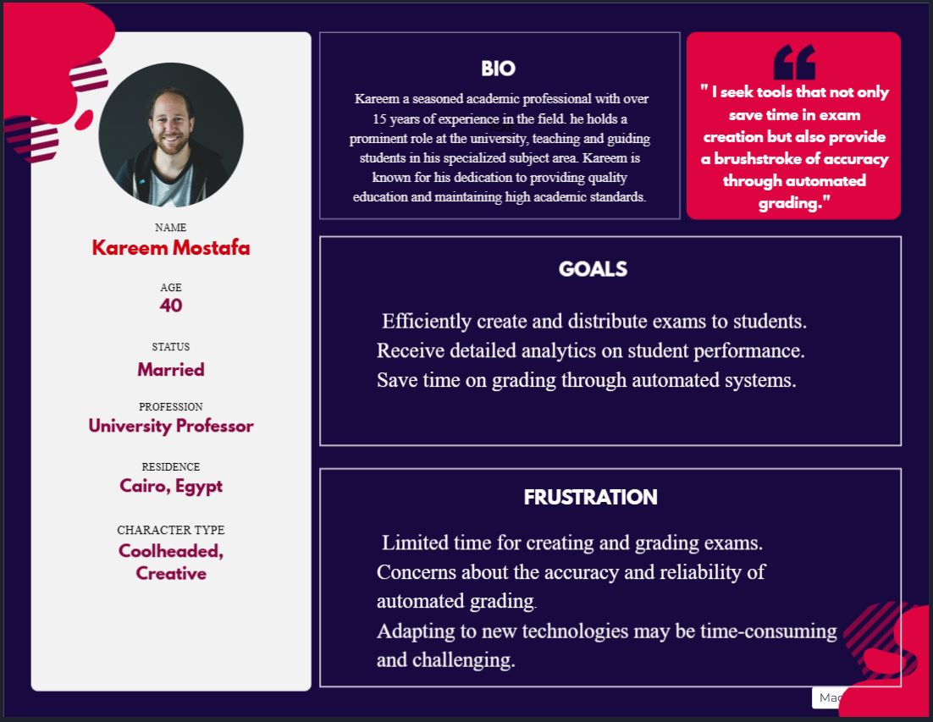

Figure 2 Persona 1

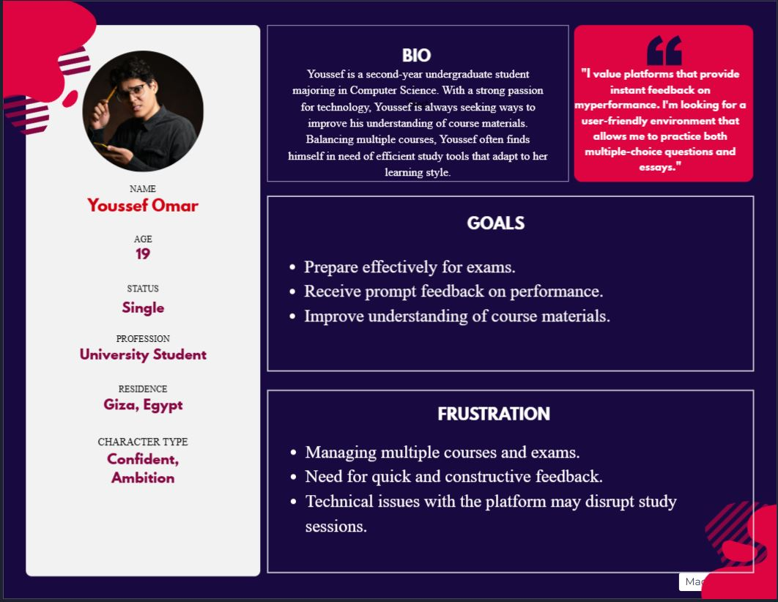

Figure 3 Persona 2

# LearnHub Design and Implementation

* 1. **Class Diagram**

Figure 4 Class Diagram

* 1. **Sequence Diagram**

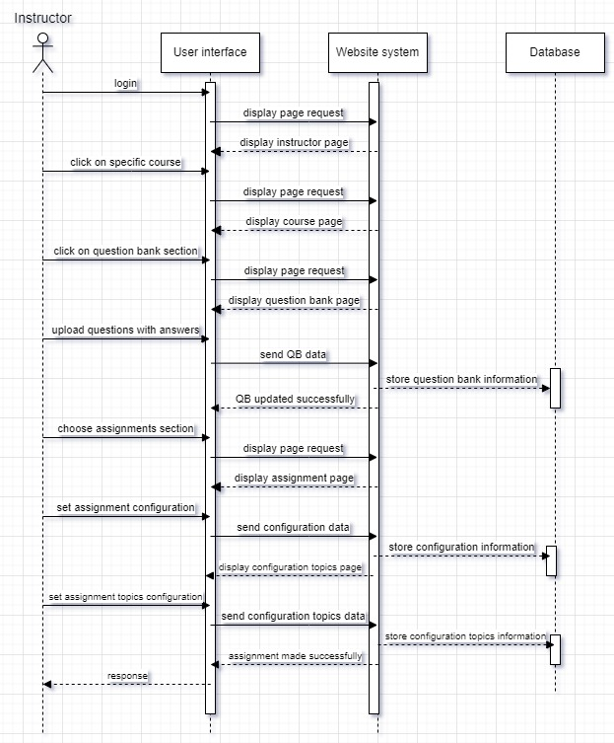

Figure 5 make quiz sequence diagram.

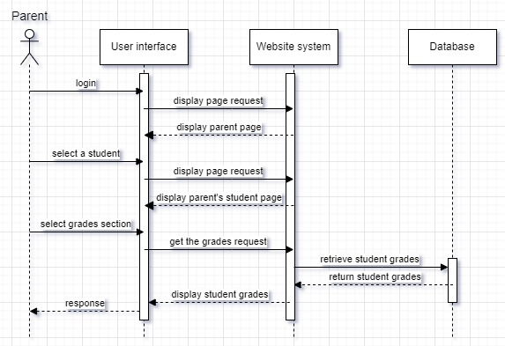

Figure 6 See student grades sequence diagram.

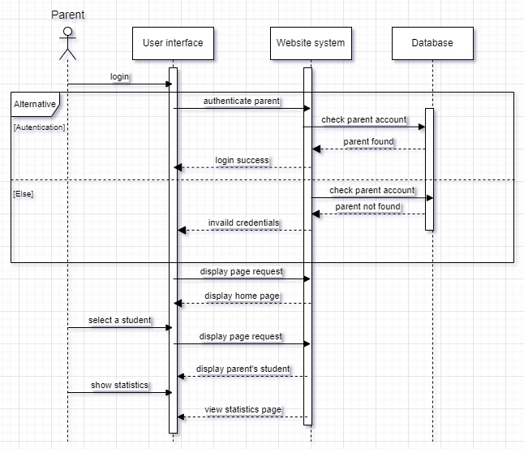

Figure 7 See student statistics on dashboard sequence diagram.

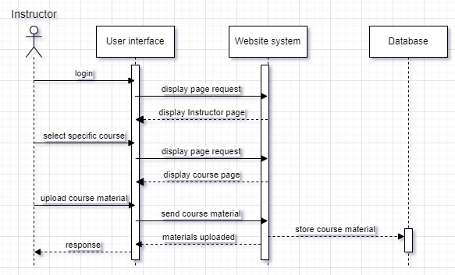

Figure 8 upload course materials sequence diagram.

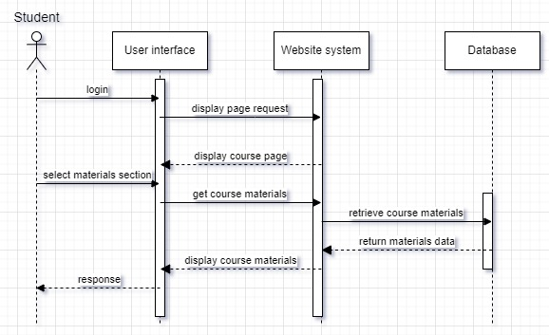

Figure 9 view course materials sequence diagram.

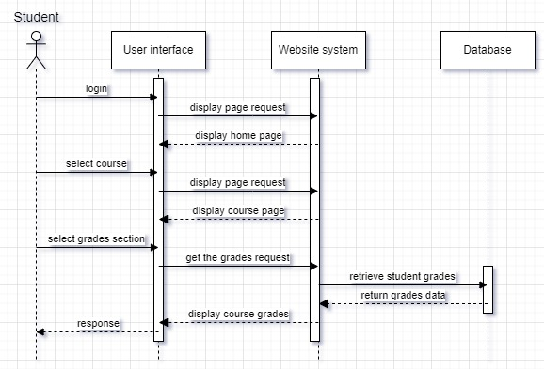

Figure 10 view grades sequence diagram.

* 1. **System Architecture**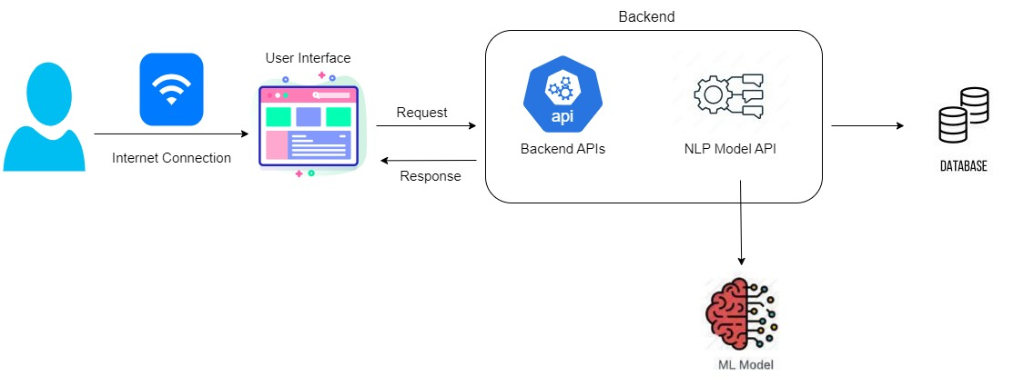

Figure 11 System Architecture

* 1. **Model Architecture**

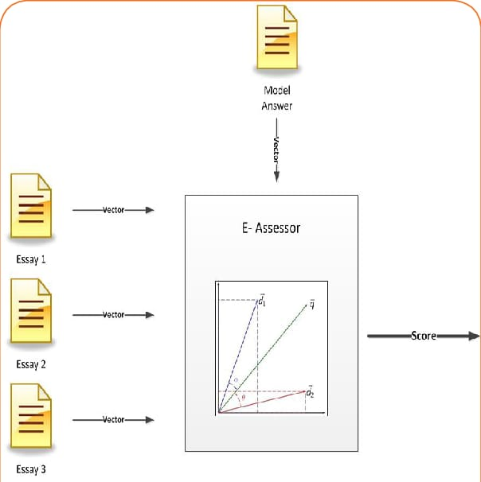

Figure 12 Model Architecture

* 1. **A diagram of a computer

     Description automatically generatedEntity-Relationship Diagram (ERD)**

Figure 13 ERD Diagram

* 1. **Activity Diagram**

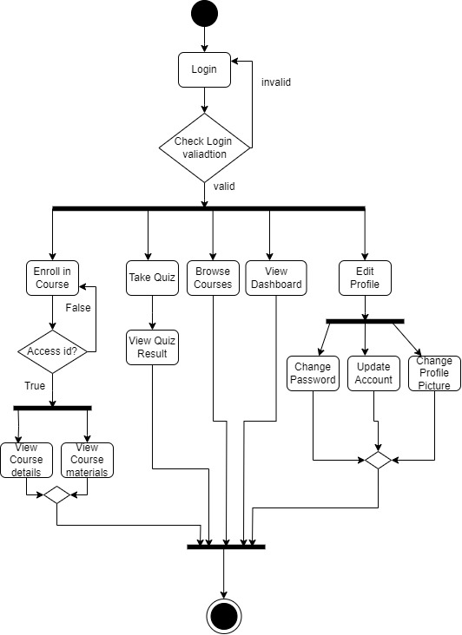

Figure 14 Activity Diagram1

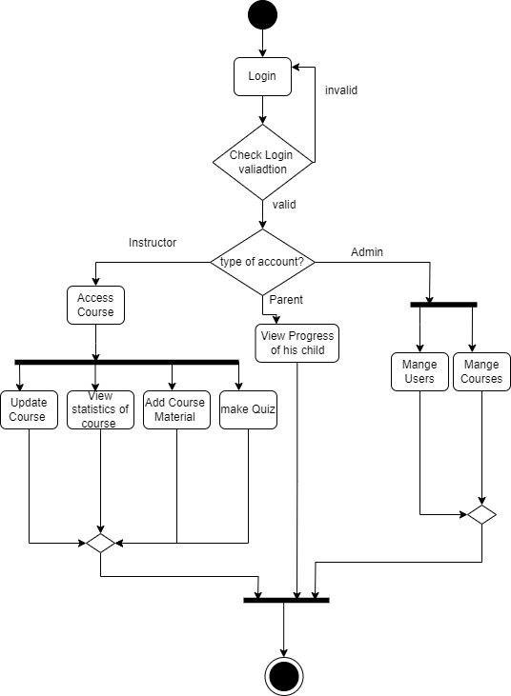

Figure 15 Activity Diagram2

* 1. **UI Prototype**

